

**Team Members**

Santhosh Kumar K

Sujjit D S

Niranjan Murthy

S K L Narayana Iyyengar Malyavantham

**Activity-1**

1. **GET operation for sold pets.**

**Base URL:** https://petstore.swagger.io/v2

**URL:** <https://petstore.swagger.io/v2/pet/findByStatus?status=sold>

**Data count = 7**

1. **Add new pet using own id, give name, give creative status rather than sold, unsold etc...**

**Base URL:** <https://petstore.swagger.io/v2/pet>

**POST request to add new data**

**Retrieving the data using ID and parameters**

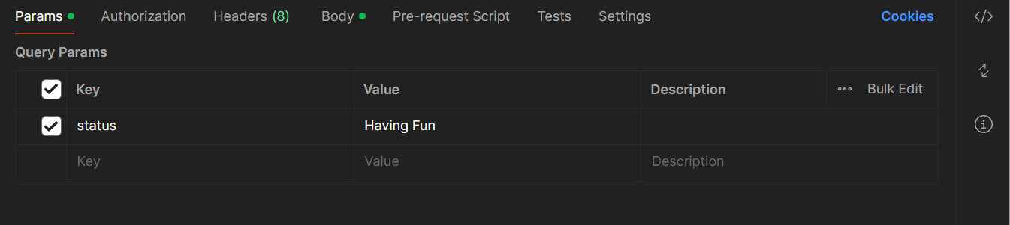

**URL:** https://petstore.swagger.io/v2/pet/findByStatus?status=Having Fun

[

    {

        "id": 15,

        "category": {

            "id": 0,

            "name": "string"

        },

        "name": "Sandy",

        "photoUrls": [

            "string"

        ],

        "tags": [

            {

                "id": 0,

                "name": "string"

            }

        ],

        "status": "Having Fun"

    }

]

**Activity 2**

**Add Pet:**

**Add a pet as previous activity, but randomize the pet ID**

**URL:** [**https://petstore.swagger.io/v2/pet**](https://petstore.swagger.io/v2/pet)

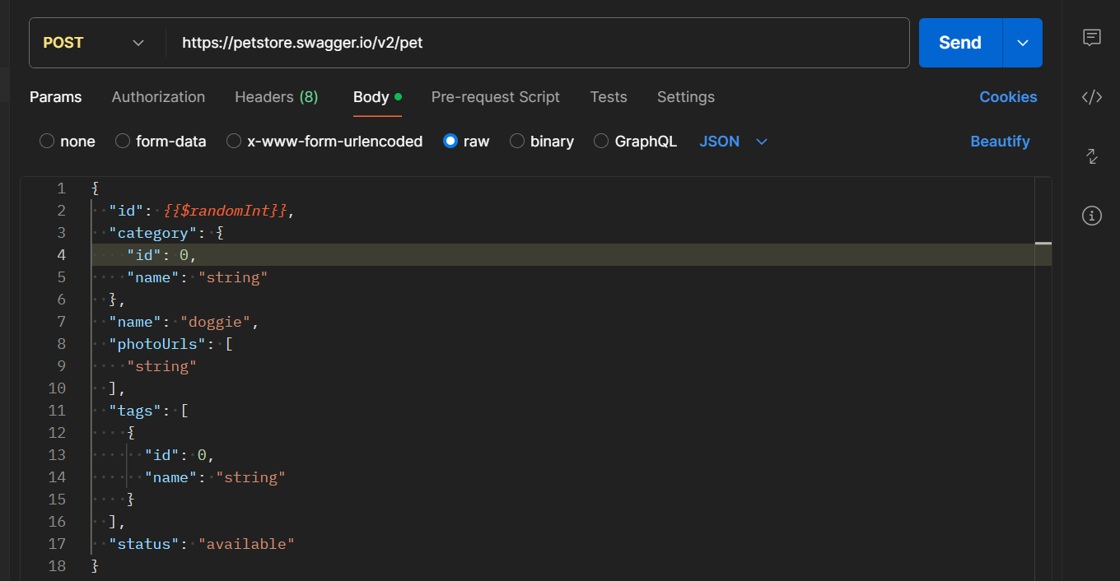

**Activity 3**

**Add a pet as previous activity but randomize the pet name as well as the pet status based on a predefined set of values.**

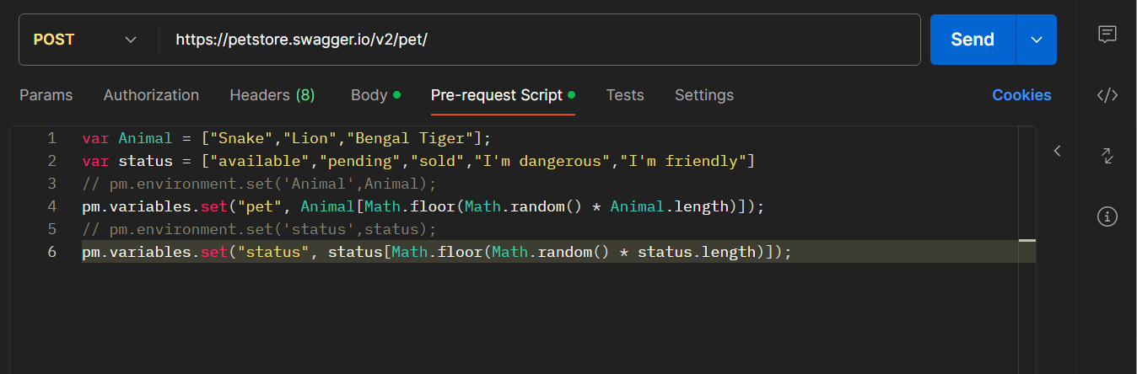

**Every time we do POST request the values of name and status changes.**

**Activity 4**

**Get Pet variation:**

**1) For the POST request as previous activity, where the pet id was randomized.**

**URL:** [**https://petstore.swagger.io/v2/pet/**](https://petstore.swagger.io/v2/pet/)

1. **Run a GET request to get the details of the pet created, using the pet id. This should be automated, not manual key-in of the pet id.**

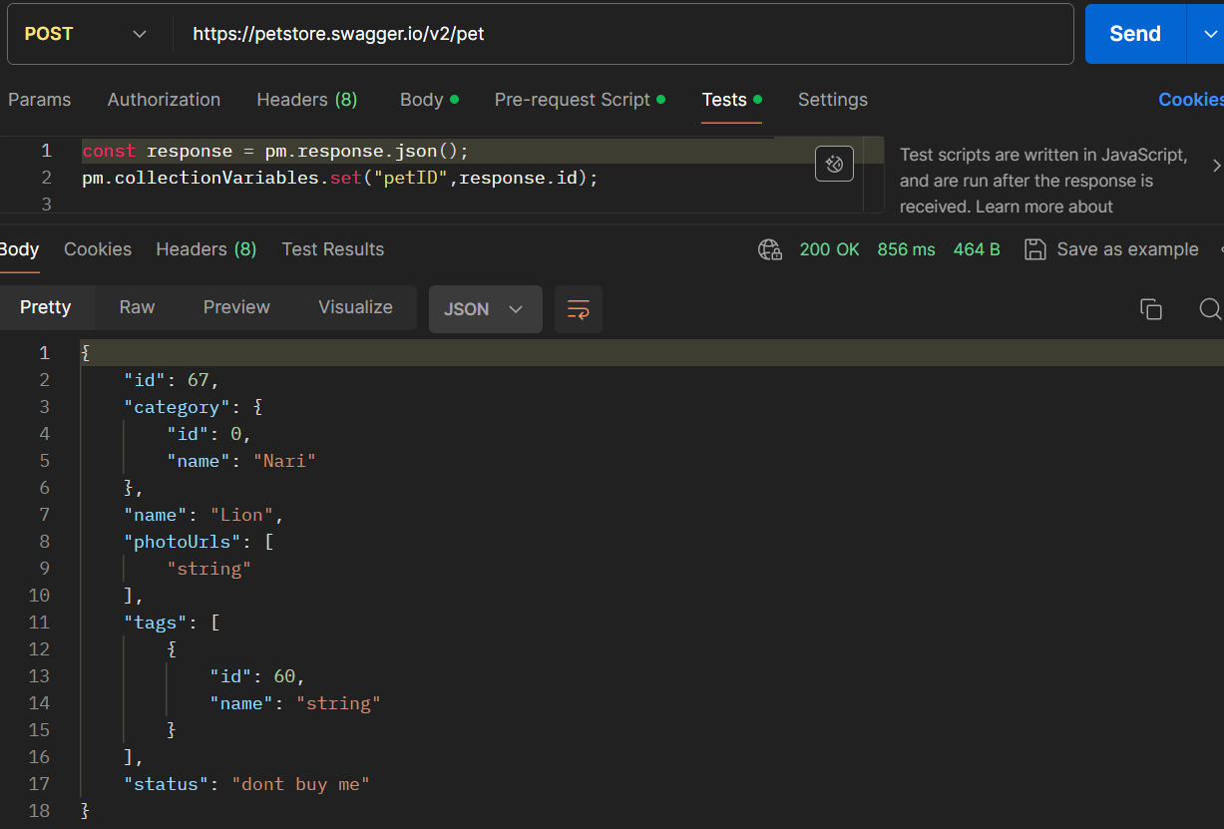

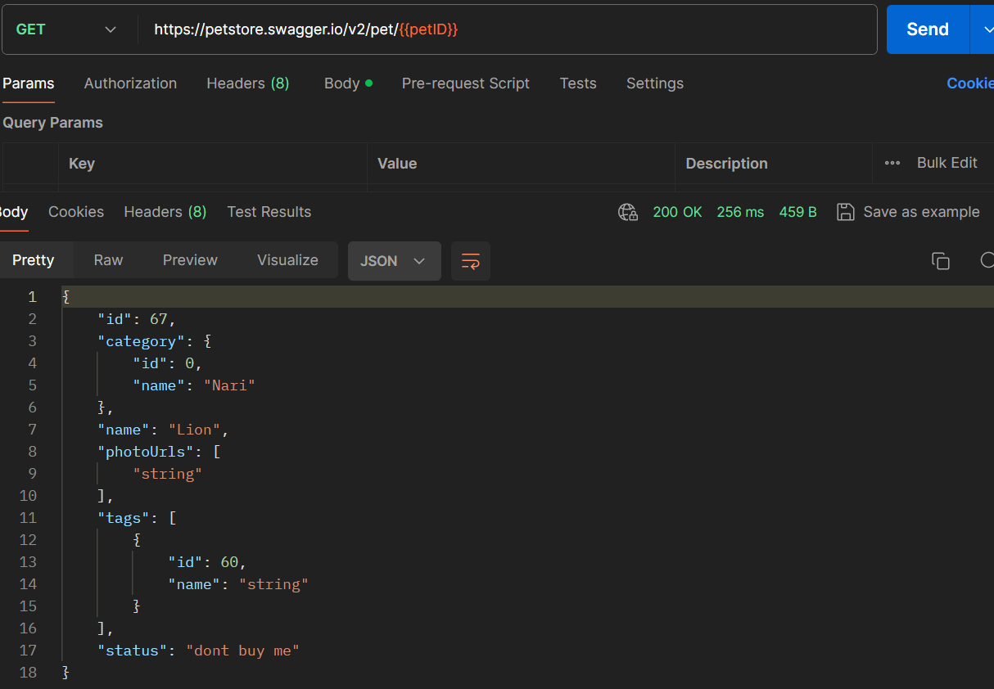

**Activity 5**

**Post/get/put/delete operations together:**

**building on top of previous activity, do the following sequence:**

* + - **POST request with randomized id, name and status**

[**URL: https://petstore.swagger.io/v2/pet/**](URL:%20https://petstore.swagger.io/v2/pet/)

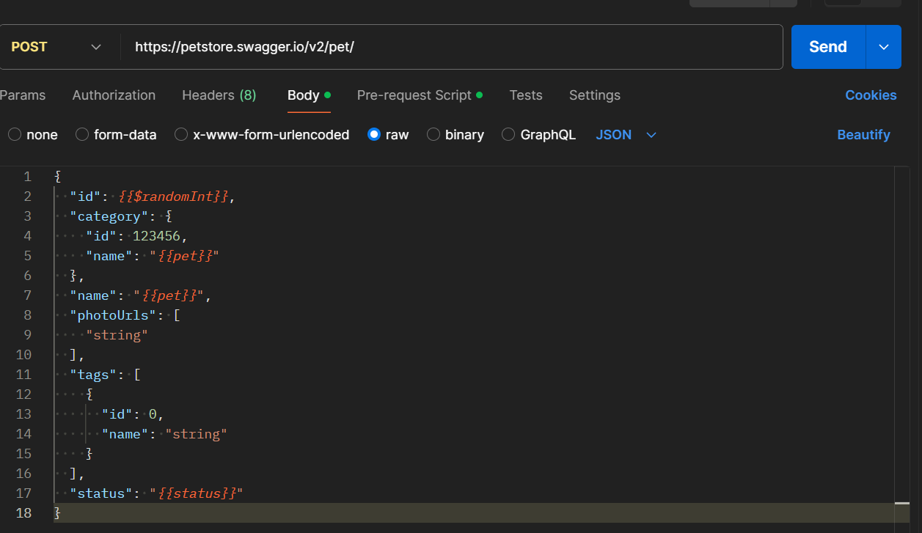

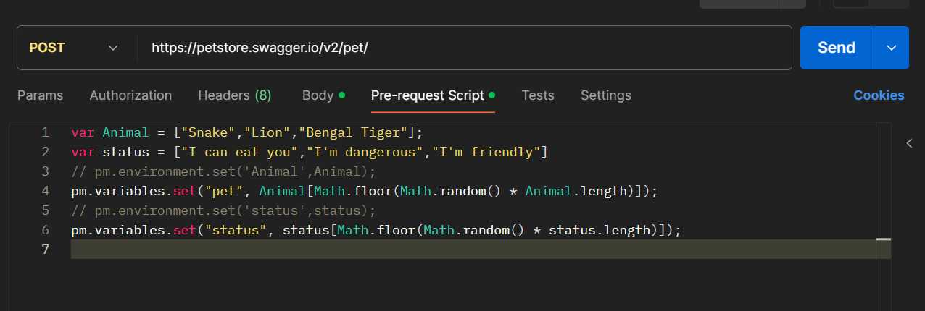

* + **GET request to get the details of the pet created previously.**

**URL: https://petstore.swagger.io/v2/pet/749**

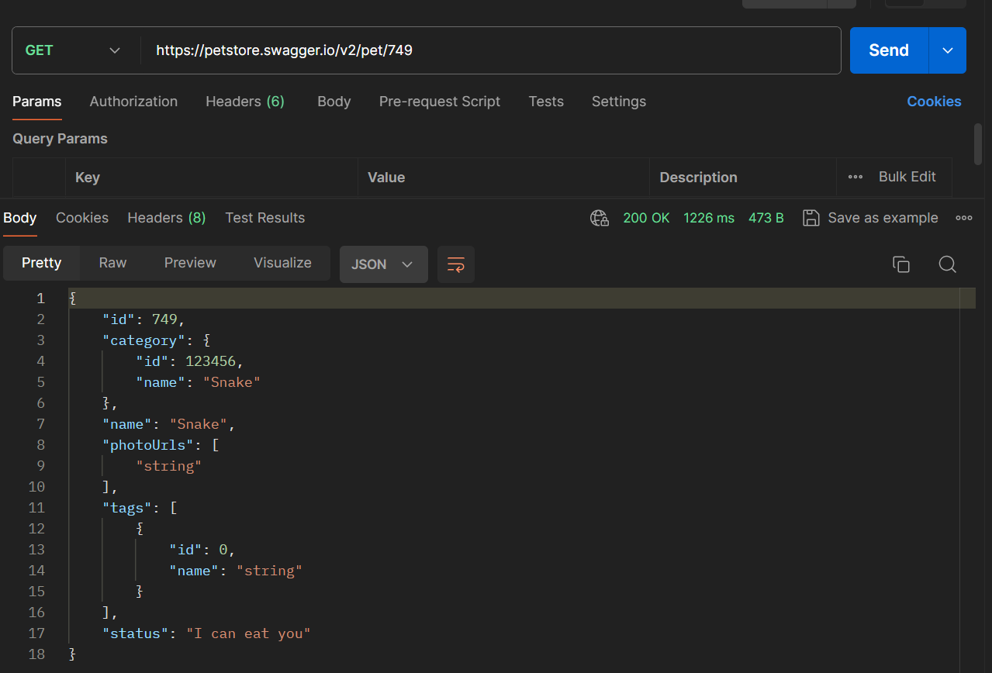

* + - **PUT request to update the status of the pet created.**

**URL:** [**https://petstore.swagger.io/v2/pet**](https://petstore.swagger.io/v2/pet)

* + - **GET request to verify that the status is actually changed.**

**URL:** [**https://petstore.swagger.io/v2/pet/749**](https://petstore.swagger.io/v2/pet/749)

* + - **DELETE request to delete the pet**

**URL:** [**https://petstore.swagger.io/v2/pet/749**](https://petstore.swagger.io/v2/pet/749)

* + - **GET request to verify that the pet cannot be found**

**URL:** [**https://petstore.swagger.io/v2/pet/749**](https://petstore.swagger.io/v2/pet/749)

**Activity-6**

1. **Create a CSV file with test data as shown.**

1. **Use the CSV test data to create POST requests.**

**URL:** [**https://petstore.swagger.io/v2/pet**](https://petstore.swagger.io/v2/pet)

1. **Use console.log to write the data being used during each request.**

**Output: Using GET request**

